|  |
| --- |
| Networking Free Stock Photo - Public Domain Pictures  Kanchan Basel (MIT231423)  [mit231423@stud.mit.edu.au](mailto:mit231423@stud.mit.edu.au)  21st May 2024  BN109  Web and Multimedia Systems  Assignment 2 (Individual Assignment) |

Table of Contents

1. Part A (Collage) 3

2. Part B (Website Development) 6

3. Appendix 7

1. Part A (Collage)  
   In order to create image like in the given question sample, I have followed the following steps and named it as “Steps to create collage”. Here is the step-by-step procedure with detailed description:
2. Downloading and extracting zip file from Moodle:

I have downloaded the zip file from our course resources and extracted the zip file to a known directory in my computer.

1. Setting Up Canvas:  
   I have opened GIMP and created a new canvas with the dimension of 600px width by 400px height as you can see in the picture below:

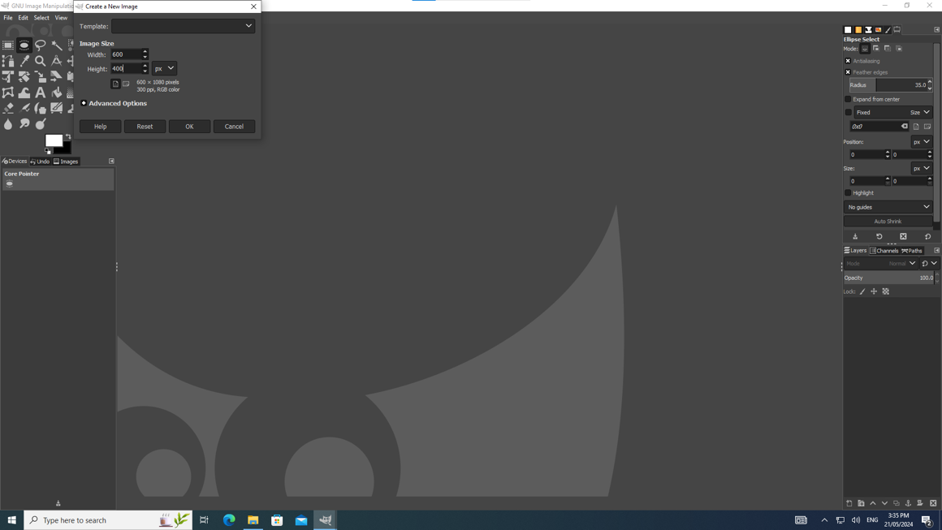

1. Adding Background:

After that I have imported the Ghandruk Mountain Image into my canvas and resized it to cover the entire canvas. I have flipped the picture as given in the picture.  
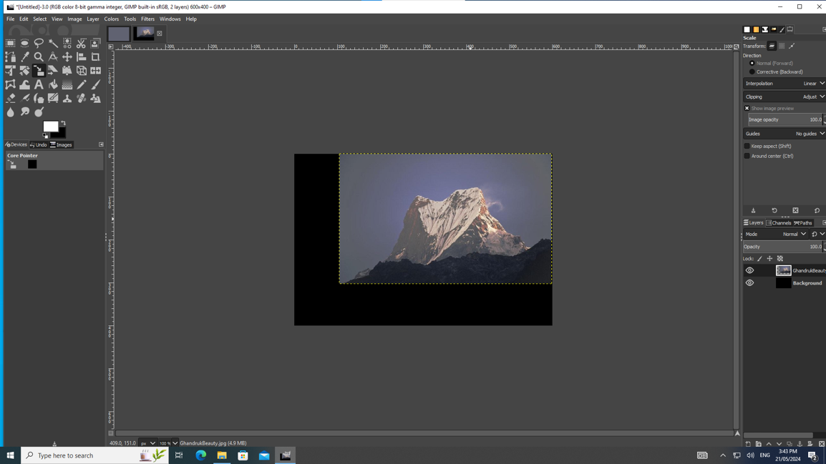   
  
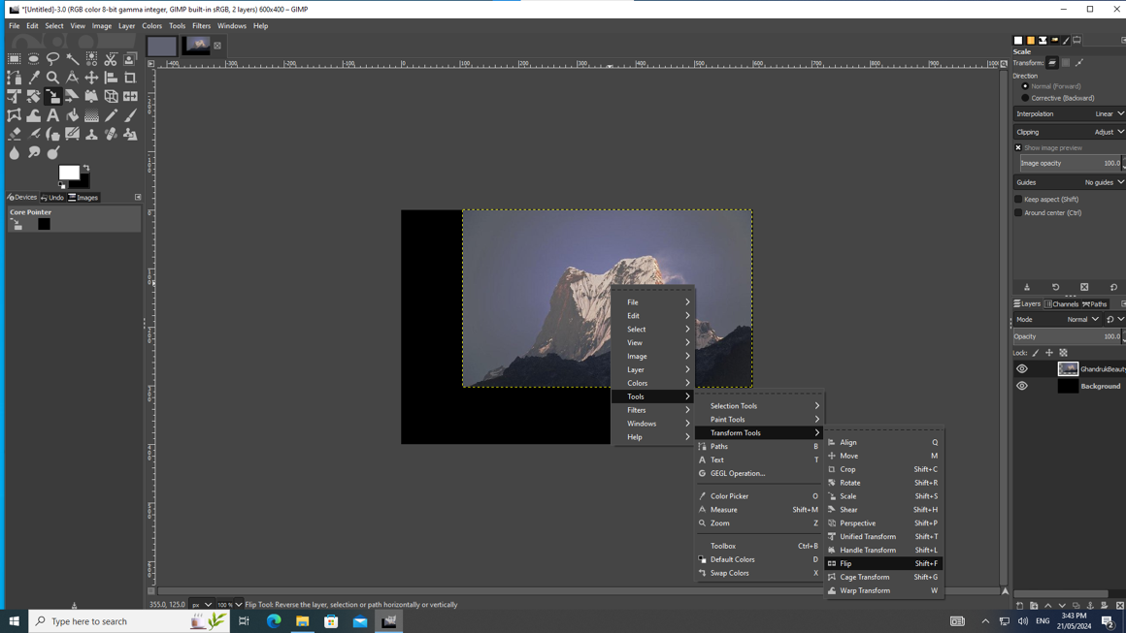

1. Adding Yoga Posture Image:

After that, I have imported the Yoga Posture Image and cropped it using elliptical crop tool and made the feather value 35 and blended it smoothly with the background.  
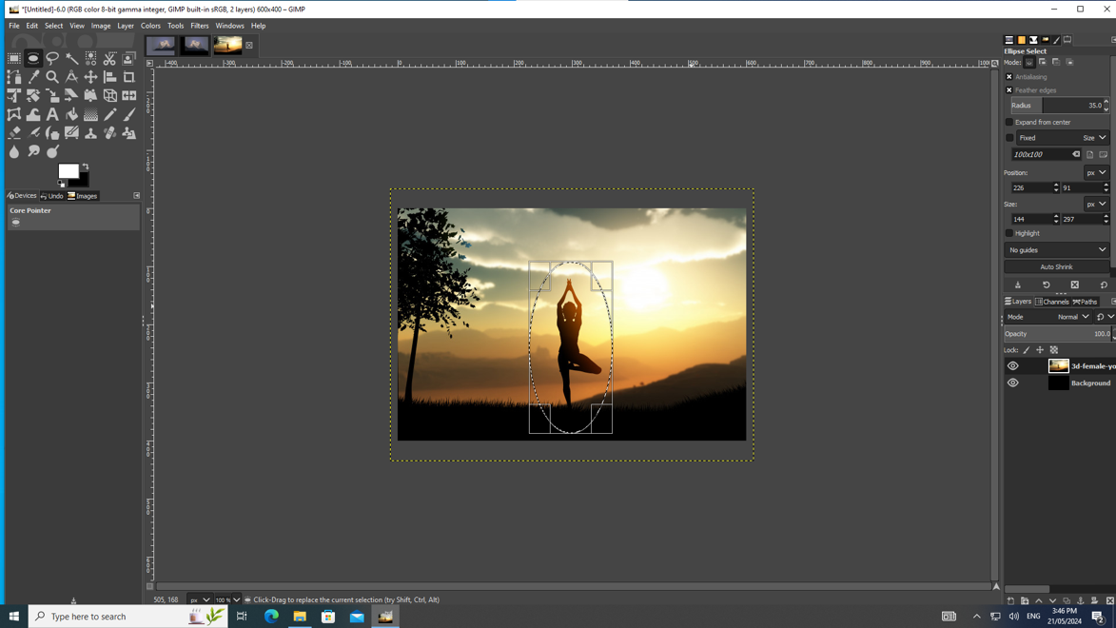

1. Adding Student ID number:

After this, I have used the text tool to add my student ID number at the bottom centre of the collage. Here, I have ensured that the font-family is Goudy Stout and set the font size to 42 points. I set the font colour to white background behind the text as shown in the sample.

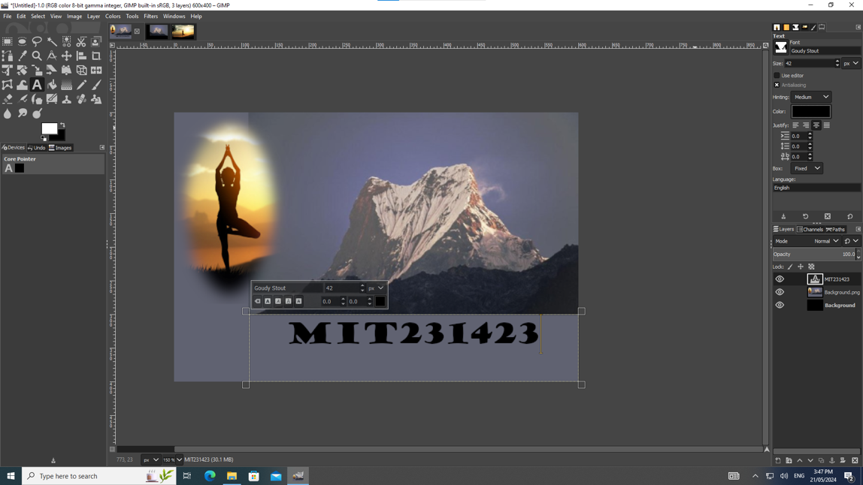  
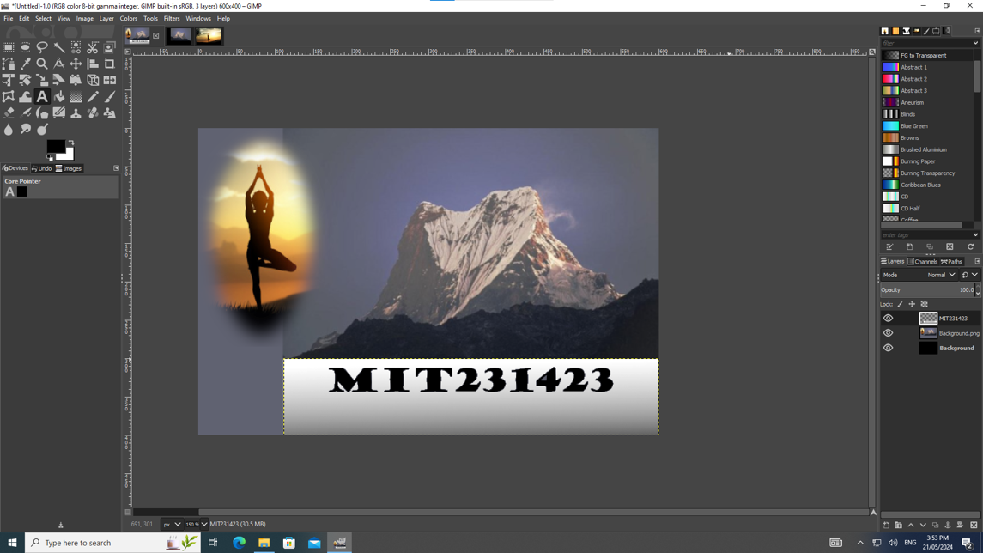

Overall, here is the result of Task A given below and I have attached the .xcf file in the assignment submission section.

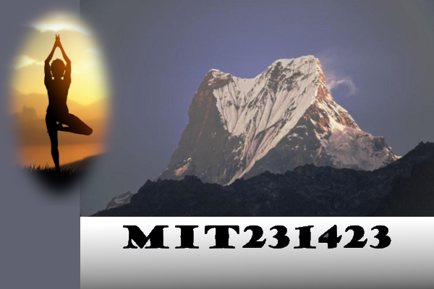

# Part B (Website Development)

Here, in part B, I have created a website that offers visitors a glimpse into my personal and academic journey within the IT realm. Starting with the homepage, I have designed a unique logo and tagline that capture the essence of my digital identity, Alongside, I have created a custom favicon to enhance professionalism.

Moving further, I have provided insights to my educational background on “Education” page that details my academic achievements from high school to my current pursuits.

In the realm of multimedia, I’ve showcased my video editing skills on “Digital Video” page that I made in Lab 10, walking visitors through the journey from raw footage to the final product. Additionally, on the Skill’s Page, I have outlined essential proficiencies required for a career in IT, embedding a relevant YouTube video to enrich visitors’ understanding.

To foster user interaction, the “Contact Us” page feature from elements for visitors to submit inquiries and comments, culminating in a courteous acknowledgement on a “Thank You” Page. Finally, a comprehensive footer across all pages integrates essential elements such as copyright information, disclaimers, and social media links, ensuring a cohesive user experience.  
  
Overall, my website development assignment shows not only my technical skills but also my commitment to user engagement and accessibility.  
  
I have submitted all the files to be attached with website in a zipped folder.  
  
Additionally, I have created a domain under my name, [www.kanchanbasel.com.np](http://www.kanchanbasel.com.np)   
which will redirect to my assignment website. I have uploaded my html and CSS in GitHub and for hosting I have chosen Cloudflare because of its durability.

# Appendix

1. <https://youtu.be/NWnBxQjssvQ?si=J9msrTuFQ9a_ZEbf>
2. <https://www.w3schools.com/>
3. <https://www.tutorialspoint.com/html/index.htm>
4. <https://www.gimp.org/>
5. <https://www.youtube.com/watch?v=LX-S1CX1HUI&pp=ygUKdXNpbmcgZ2ltcA%3D%3D>
6. <https://chat.openai.com/>